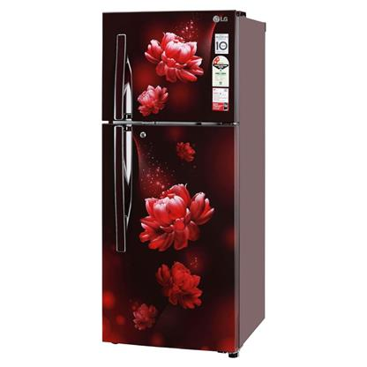

***LG REF 7770LF AVANTE Double Door Refrigerator***

* **Color:**Silver
* **Available:**Out of Stock
* **Dimension:**11*5*200
* **Compressor:**Inverter

**Old Price:**~~Rs 402,000.00~~

**New Price:**Rs 301,999.00